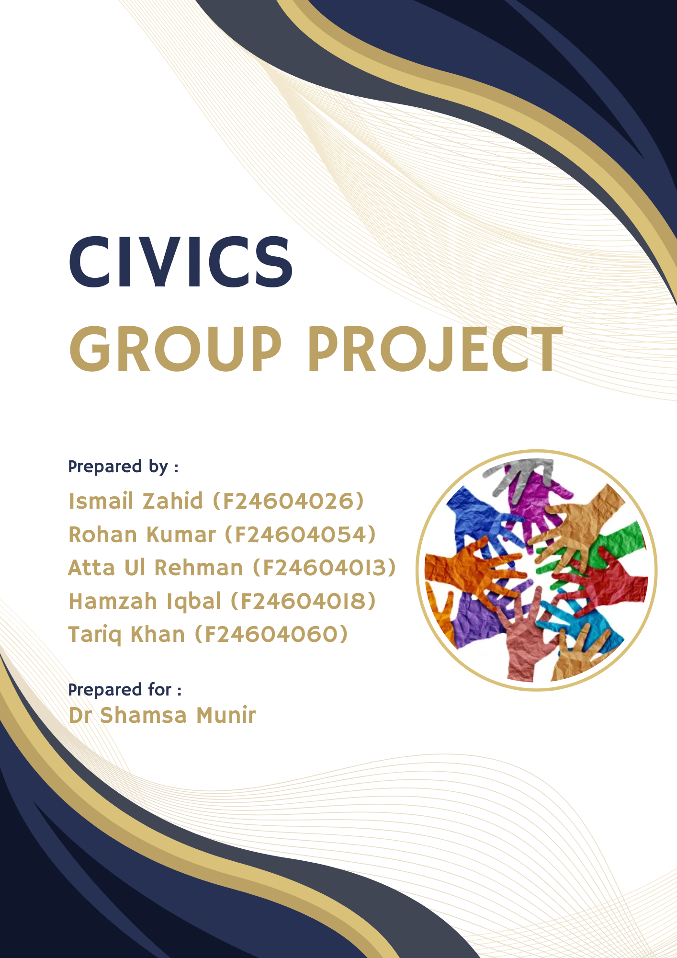

Contents

INTRODUCTION to RACI MATRIX and Identifying the Stake holders (Atta-ul-Mustafa): 3

Define Tasks (Ismail Zahid): 5

Determining which Stakeholders are Responsible, Consulted (Muhammad Hamzah Iqbal): 6

Determining which stake holders are Accountable and Informed (Rohan Kumar): 7

CONCLUSION (Tariq Khan): 9

# INTRODUCTION to RACI MATRIX and Identifying the Stake holders (Atta-ul-Mustafa):

DEFINING THE RACI MATRIX:

RACI Matrix is a project management tool which is used to make an proper distribution of responsibilities and tasks while doing a project or any task.

BENEFITS OF USING RACI MATRIX:

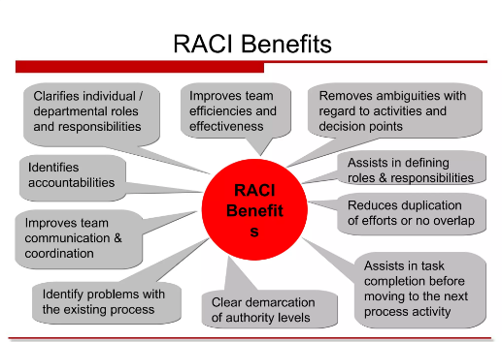There are several benefits of using RACI matrix which are listed as follows:

1. It clarifies the responsibilities and roles of everyone in the project and gives everyone the direction that what to do.
2. Avoids the overlapping of the tasks.
3. Effective communication and collaboration.
4. Promotes accountability by defining the tasks.

DEFINING COMPONENTS OF RACI MATRIX:

RESPONSIBLE:

This is the person who is directly performing the task and is also responsible for the task.

ACCOUNTABLE:

This is the person who is supervising the task and takes the person who is responsible for task and he himself is responsible for the project.

CONSULTED:

This is the person who is consulted in this regard and he is like an expert in the task and his recommendations are considered seriously.

INFORMED:

These are the people who needed to be addressed about the project i.e stakeholders.

APPLYING RACI MATRIX ON LOCAL JOB FINDING APP:

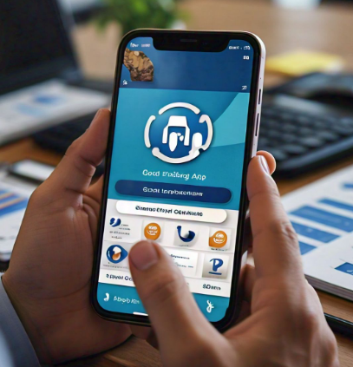We will apply RACI matrix on the local job finding app which would assist people in finding new opportunities for jobs. Which would make the process of finding jobs for them easy and help them with targeted job search.

To apply RACI matrix on this project we will break it into components and then apply the roles and responsibilities of everyone on it in order to assign the roles and responsibilities.

IDENTIFYING STAKE HOLDERS:

We would divide the stake holders in the following manner:

PRIMARY STAKEHOLDERS:

1. Job seekers: all the persons looking for the jobs.
2. Employers: all the companies and organizations looking for hiring the peoples.

SECONDARY STAKEHOLDERS:

1. Investors: who would invest in the app.
2. Government agencies: who are responsible for job creation.
3. Recruitment agencies: which specialize in finding candidates for employers.
4. Industry associates.



# Define Tasks (Ismail Zahid):

Breaking the project into smaller, clear tasks that are easy to follow:

Define Project Scope:

* Focus the project on connecting local job seekers with nearby job opportunities and employers.
* Understand who will use the app, including job seekers, local businesses, and potential government or community partners.
* Look into local job markets to find gaps and opportunities

that the app can help with, making sure it’s useful and

relevant for users.

Prioritize Features for MVP:

* Start with a comprehensive list of app features, including job alerts and user profiles.
* Ensure the chosen features can be developed efficiently while providing value.

Set Timelines for Each Task:

* Develop a clear timeline outlining all phases of the project, including design and launch.
* Monitor progress against the timeline and make adjustments as needed.

Define Success Metrics:

* Identify key performance indicators like downloads, job applications, and user engagement.
* Implement surveys and feedback to gauge user satisfaction.
* Use collected data to refine and improve the app over time.
* Regularly communicate performance outcomes to keep the team informed.

# Determining which Stakeholders are Responsible, Consulted (Muhammad Hamzah Iqbal):

The RACI matrix includes four key elements of which two are Responsibleand Consultants**.** The people responsible are those directly involved in completing tasks or delivering specific outcomes. They are the ones doing hands-on work. The second aspect Consulting involves seeking input from experts or stakeholders who provide valuable feedback to elevate the project and improve user engagement.

 **Responsible:**

1. Employers:

Post job opportunities, provide accurate job descriptions, and offer feedback on applicants. They also ensure that job postings are current, accurate, and according to local labor laws.

1. Developers

Developers are responsible for building the app's code and features. They create job-matching algorithms, job listing pages, user profiles, and any interactive tools that allow users to search and apply for jobs.

1. Testers/Quality Assurance (QA)

QA testers are responsible for finding bugs and issues in the app before it’s released to the public. They test all the features to make sure everything works correctly, and that the app is user-friendly. Each of these people is responsible for a specific part of the project, ensuring that the app is functional, secure, and easy to use.

1. Cybersecurity Experts

These experts are responsible for implementing security measures like data encryption and secure login methods. They make sure the app is protected from hackers and user data always stays safe.

**Consulted:**

As the name suggests, consulted people are those who help to make the project better by providing valuable insights. They provide input, expertise and guidance for a specific task in the project. Their feedback is considered to ensure smooth progress and maintain high quality. In the case of our Community Job seeking app, people who may be useful for consultation are:

1. User Interface Designers

User interface designers help decide how the app will look and feel when people use it. They focus on things like how job listings are shown and how users can upload their resumes. Their job is to make sure the app is easy to use and looks nice, so people enjoy using it and don't get frustrated.

2. Legal Team

The legal team makes sure the app follows employment laws and protects user data. Since the app will have a lot of personal information, like resumes and contact details, legal advisors help prevent issues like data leaks. They make sure everything is legal and secure so users can trust the app.

3. Recruitment Consultants

Recruitment consultants give advice on what features would help both job seekers and employers. They suggest things like how to make the job-matching system better and how to improve keyword searches, so job seekers can find the right job and employers can find the right candidates faster.

4. Market Analysts

Market analysts study other job apps to figure out what’s working and what’s not. They help the team add features that will make this app stand out from the competition. Their advice helps the app become more popular by offering something unique that other apps don’t have.

5. Data Scientists

Data scientists help make the app smarter by analyzing data to improve the job-matching system. They look at information like job listings and user profiles to make sure the app suggests the best jobs for each person. Their work makes the app better at finding the right jobs for users based on their skills and experience.

# Determining which stake holders are Accountable and Informed (Rohan Kumar):

In the context of a local job searching app that provides real time job availability within a community and helps match job seekers with employers, its essential to identify the stakeholders involved and determine who is accountable and who should be kept informed. Here are the key aspects of:

Accountable:

* App Development Team (Designers, Developers, Data Scientists ):

1. Role: They are responsible for building, maintaining, and improving the app, ensuring it runs smoothly, delivers accurate information, and integrates necessary features.
2. Accountability: Responsible for the apps functionality, data accuracy, and user experience.

* Job seeking users ( jobless individuals ):

1. Role: Actively using the apps to search for employment opportunities.
2. Accountability: They are responsible for keeping their profiles up to date, being truthful in their applications, and responding to job offers or rejections.

* Employers ( Local businesses and Companies):

1. Role: Posting job opportunities, providing accurate job descriptions, and offering feedback on applicants.
2. Accountability: Ensuring that job postings are current, accurate, and compliant with local labor laws.

App Administrators/Moderators:

1. Role: Monitoring the app for inappropriate, ensuring qualify control, handling disputes or complaints, and verifying employer authenticity.
2. Accountability: Overseeing the platforms compliance with regulations and handling issues related to fake or misleading job postings.

Data Privacy Officers:

1. Role: Ensuring the app complies with data protection laws (GDPR, etc.), safeguarding personal data of users, and establishing data security protocols.
2. Accountability: Ensuring that user data (both employers and job seekers) is kept secure, private, and used responsibly.

Informed refers to keeping relevant parties updated on progress or decisions without requiring their direct input, ensuring transparency and smooth communication. Both roles are crucial for successful project management and execution.

Stakeholders Informed (Key Parties Needing Updates):

* Local Community/Job Market:

1. Role: The overall pool of potential job seekers and employers within the community.
2. Informed: Regular updates on the availability of jobs, trends in the job market, and any changes or improvements in the app.

* Government/Local Authorities:

1. Role: Potentially providing support or oversight for the app as part of a broader employment initiative.
2. Informed: Should be updated on the apps effectiveness in reducing unemployment, how it supports local economic growth, and any concerns about compliance with employment laws or regulations.

* Investors/Sponsors:

1. Role: Funding the development and ongoing operation of the app.
2. Informed: Regular updates on the apps performance, user growth, profitability, and overall impact on the local job market.

* Marketing Teams/Community Outreach:

1. Role: Responsible for spreading awareness about the app and bringing more users (both employers and job seekers) onto the platform.
2. Informed: Kept in the loop about changes in features, user feedback, or any technical issues that could impact promotion.

* Third-party Service providers (e.g. Payment Platforms, Background Check Providers):

1. Role: Supporting the app with various functionalities like payment processing for premium services or background verification services for job candidates.
2. Informed: Notified of changes in the app’s infrastructure, user agreements, or services needs.

# 

# CONCLUSION (Tariq Khan):

In conclusion, the use of the Raci Matrix has clearly defined the role in the development of applications to seek work, and has helped to provide a well-organized approach.The purpose of this application is to support users, provide personalized recommendations, network abilities, and make job finding process more efficient.

**Problems faced in our project:**

To involve the community in our app, we need to attract enough users, both job seekers and employers. Some people prefer traditional job search methods and may be hesitant to use the app.Additionally, updating job postings and securing user data will be required. Solving these problems and actively interacting with the community can maximize the benefits of applications and improve the employment opportunities for everyone in their respective fields.

**How will our project engage our community and make improvement in the community?**

Engaging your community through our job search app fosters collaboration and can make a positive impact in several ways:

* **Local partnerships:** Through partnerships with local businesses, organizations, and educational institutions, we can ensure that our application contains up-to-date job listings and training opportunities that meet the needs of our community.
* **Community feedback:** By actively seeking feedback from our users, we can continuously improve our app based on their experiences and suggestions. This feedback loop helps build trust and encourage continued interaction.
* **Skills Development Workshops:** Empower community members and improve their employability by offering workshops and training sessions on resume writing, interview techniques, and other job search skills.
* **Mentoring Programs:** Facilitate connections between experienced professionals and job seekers who can receive valuable advice, support, and networking opportunities.
* **Success stories:** Highlighting success stories of users who have found employment through the app can inspire others and reinforce the value of the app in the community.
* **Continuous improvement:** Regularly updating the app based on community needs and Labor market trends ensures that it remains relevant and effective.

By engaging the community in these ways, our project can help create a supportive ecosystem that not only helps job seekers, but also contributes to the overall economic and social development of the region.